06/10/2026 - Task
Completed By:Vimala Rani A(212223040240)

Selenium Web Automation – Amazon E-Commerce Website
Develop a Selenium WebDriver automation script using Python to automate the following user journey on the Amazon website:

from selenium import webdriver
from selenium.webdriver.common.by import By
from selenium.webdriver.common.keys import Keys
from selenium.webdriver.support.ui import WebDriverWait
from selenium.webdriver.support import expected_conditions as EC

driver = webdriver.Chrome()
wait = WebDriverWait(driver, 15)

def find_click(selectors):
for by, value in selectors:
try:
e = WebDriverWait(driver, 5).until(
EC.presence_of_element_located((by, value))
)
if e.is_displayed():
driver.execute_script("arguments[0].click();", e)
return True
except:
pass
return False

driver.get("https://www.amazon.in/")
driver.maximize_window()

search = wait.until(
EC.element_to_be_clickable((By.ID, "twotabsearchtextbox"))
)
search.send_keys("wireless mouse")
search.send_keys(Keys.ENTER)

products = wait.until(
EC.presence_of_all_elements_located(
(By.XPATH, "//div[@data-component-type='s-search-result']")
)
)

added = False

for p in products:
try:
link = p.find_element(
By.XPATH,
".//a[contains(@href,'/dp/') or contains(@href,'/gp/product/')]"
)
driver.get(link.get_attribute("href"))

if find_click([
(By.ID, "add-to-cart-button"),
(By.NAME, "submit.add-to-cart"),
(By.ID, "add-to-cart-button-ubb"),
(By.CSS_SELECTOR, "input[value='Add to Cart']"),
(By.CSS_SELECTOR, "input[title='Add to Shopping Cart']")
]):
added = True
break
except:
pass

if not added:
print("Add to Cart failed")
driver.quit()
exit()

find_click([(By.ID, "nav-cart")])

if not find_click([
(By.NAME, "proceedToRetailCheckout"),
(By.XPATH, "//input[contains(@name,'proceedToRetailCheckout')]"),
(By.XPATH, "//span[contains(.,'Proceed to Buy')]/ancestor::a[1]"),
(By.XPATH, "//span[contains(.,'Proceed to Buy')]/ancestor::button[1]"),
(By.ID, "sc-buy-box-ptc-button")
]):
print("Proceed to Buy failed")
driver.quit()
exit()

wait.until(lambda d: "signin" in d.current_url.lower())

print("Amazon login page opened")
print("Automation stopped")

input("Press ENTER to close...")
driver.quit()

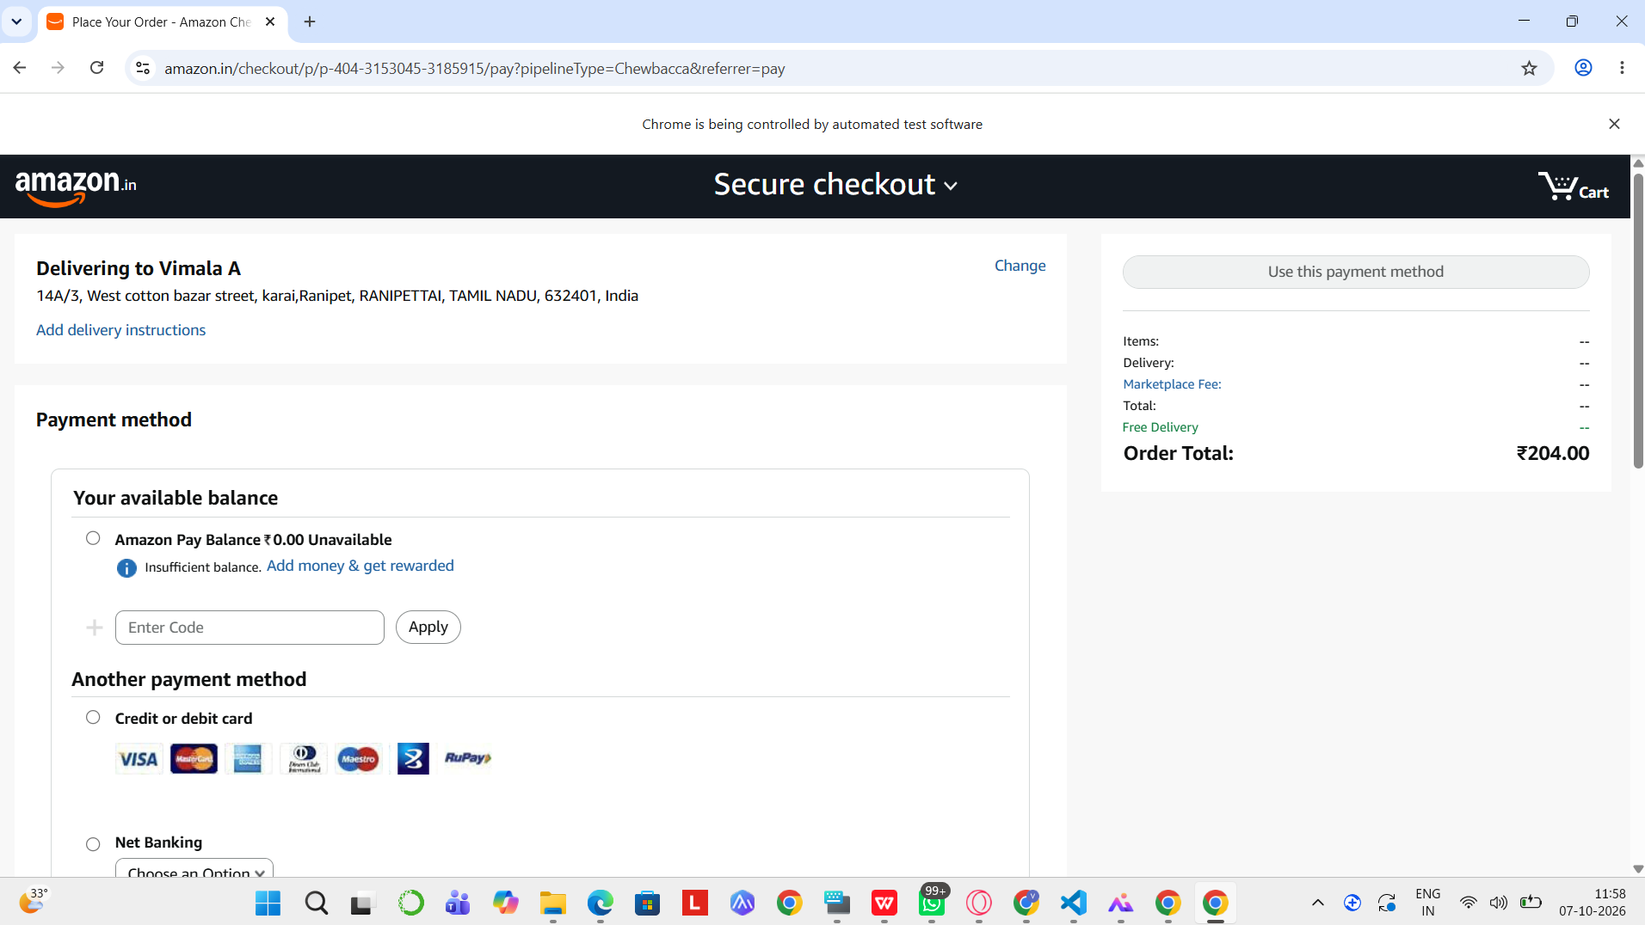
Github link: https://github.com/vimalaraniA/testcase.git

